🎃 Halloween Project: The Halloween Town 🏚️

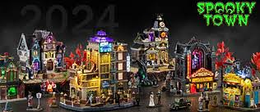
Welcome Grade 6! Imagine that I am a tourist coming to your spooky town and you with your team need to make me have a guided tour of the place.
You and your team (4 students) will create and build your own spooky Halloween Town! You will use cardboard or any recycled materials to construct your town.
Your mission:
1. Give a scary name to your town.
2. Imagine that tourists will visit your Halloween Town.
3. Describe 5 specific community places in your town (examples: cemetery, haunted library, witch’s bakery...) and introduce me to the people working there. You can give them names and personalities.
4. Invent 3 peculiarities of your town (strange traditions, weird laws, mysterious weather, unusual citizens, etc.).
5. Along with your teammates, do a presentation of around 7-10 minutes of your town. Make it sound fun and yet scary!
Date of presentation: Monday 27th October

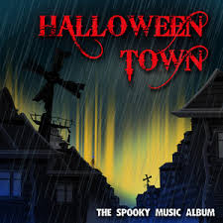

✅ Project Checklist
☐ We worked in a team of 4.
☐ We used cardboard or recycled materials.
☐ We gave a scary name to our town.
☐ We described 5 community places.
☐ We invented 3 peculiarities of the town.
☐ We made the town spooky and creative.

📊 Project Rubric (Total: 50 points)
Criteria | Points
Creativity, Originality & teamwork | 10
Town Construction (use of materials) | 10
Content (Name, place, people, peculiarity) | 15
Speaking skills (clarity, pronunciation, voice, fluency, eye contact, intonation) | 15
